VISVESVARAYATECHNOLOGICAL UNIVERSITY

“JnanaSangama”, Belagavi – 590018, Karnataka.
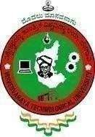
A Report on

“AICTE ACTIVITY POINT PROGRAMME”
Submitted in partial fulfillment for the award of Degree of

BACHELOR OF ENGINEERING
in

DEPARTMENTOFINFORMATIONSCIENCEANDENGINEERING

Submitted By
Nagaraj Suresh Gudagi (1DB22IS085)

Department AICTE Activity Faculty Incharge
Dr. Salma Jabeen
Associate Professor
Dept of Information Science and Engineering Don Bosco Institute of Technology
NSS Officer/AICTE Co-Ordinator of the College Dr. Bhavyashri Shetty
Professor, Department of Physics Don Bosco Institute of Technology
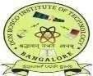

DON BOSCO INSTITUTE OF TECHNOLOGY
Kumbalagodu, MysuruRoad, Bengaluru-560074
2022-26

Don BoscoInstitute of Technology

Kumbalagodu, Mysuru Road, Bengaluru-560074 DEPARTMENT OF INFORMATIONSCIENCE& ENGINEERING
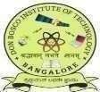

AICTE Activity Point Programme CERTIFICATE

This is to certify that the AICTE Activity Point Programme has been successfully carried out by Nagaraj Suresh Gudagi bearing USN 1DB22IS085, bonafide student of Don Bosco Institute of Technology, in partial fulfillment of the requirements for the award of the degree of Bachelor of Engineering in Information Science and Engineering of Visvesvaraya Technological University, Belagavi during the academic year 2022-2026. It is certified that all corrections/suggestions indicated for Internal Assessment have been incorporated in the report. The AICTE Activity Point Programme report has been approved as it satisfies the academic requirements in respect of AICTE Activity Point Programme for the said degree.

………………. Signature of Guide
Dr. Ramya K V AssociateProfessor Dept. of ISE

………………… Signature of the Dept. Coordinator Dr. Salma Jabeen Associate Professor Dept. of ISE DBIT, Bengaluru

…….……………. Signature of the HOD
Dr. Basavaraj G M Professor & Head Dept. of ISE
DBIT, Bengaluru

…….…………….
Signature of
College Coordinator Dr. Bhavyashri Shetty Professor
Dept. of Physics DBIT, Bengaluru
.

…………………. Signature of the Principal
Dr. Naghabhushana B S
Principal
DBIT, Bengaluru

i

Don BoscoInstitute of Technology

Kumbalagodu, Mysuru Road, Bengaluru-560074 DEPARTMENT OF INFORMATIONSCIENCE& ENGINEERING

DECLARATION

I, Nagaraj Suresh Gudagi, bearing the USN 1DB22IS085, student of Bachelor of Engineering, Information Science and Engineering, Don Bosco Institute of Technology, Kumbalagodu, Bengaluru, hereby declare that the AICTE Activity Point Programme work has been carried out by me under the supervision and guidance of Department Staff Coordinators and submitted by me as a partial fulfillment for the award of the Bachelor of Engineering degree in Information Science and Engineering from Visvesvaraya Technological University, Belagavi during the academic year 2022-2026.

I here by declared that the AICTE activity point work has been carried out at following partner organizations :
- Yerehalli Grama Panchayathi, Ramanagar
- Government Higher Primary School, Yerehalli, Ramanagar 562159

Nagaraj Suresh Gudagi ( 1DB22IS085)

ACKNOWLEDGEMENT

The satisfaction and euphoria that accompany the successful completion of any task would be incomplete without the mention of the people who made it possible, whose constant guidance and encouragement crowned the efforts with success.

I would like to profoundly thank Management of Don Bosco Institute of Technology, For providing such a healthy environment for the successful completion of Project work.

I would like to express my thanks to Dr. B S Naghabhushana, Principal, Don Bosco Institute of Technology, Bengaluru for his encouragement that motivated me for the successful completion of AICTE activity.

It gives me immense pleasure to thank Dr. Basavaraj G M, Professor and Head of Department, Information Science and Engineering for his constant support and encouragement.

I would like to express my deepest sense of gratitude to my AICTE Activity Points Coordinator Dr. Salma Jabeen, Associate Professor Department of Information Science & Engineering for her constant support and guidance throughout the activity.

I would like to express my deepest sense of gratitude to my Guide Dr. Ramya K V associate Professor Department of Information Science & Engineering for her constant support and guidance throughout the activity.
I am also deeply thankful to Yerehalli Grama Panchayathi, Ramanagar for their invaluable support in offering meaningful volunteering opportunities and resources.

Also, I would like to thank all teaching and non-teaching staff of Department of Information Science & Engineering who have helped directly and indirectly throughout the project work.

Nagaraj Suresh Gudagi (1DB22IS085)

WORK CONTENT

Sl. No | Activity Heads | Fromdate- To date | Number of Week | Total No of Hours | Performance Appraisal / Points earned | Remarks
1 | A1: Helping local schools to achieve good result & enhance their enrolment in Higher/ Technical/ Vocational Education | 28-03-24 to  13-04-24 | 2 weeks | 120  Hours
2 | A7: To Skillrural population | 29-08-24 to  16-09-24 | 2 weeks | 120  Hours
3 | A8:Facilitating100% Digitized money transactions | 05-02-25 to  09 -02 – 25  15-02-25  16-02-25  22-02-25  23-02-25  01-03-25  02-03-25  08-03-25  09-03-25  15-03-25 | 2 weeks | 90  Hours
4 | A10: Developing and managing efficient garbage disposal system | 11- 07-25 to  24 -07 - 25 | 2 weeks | 90  Hours
5 | A15: Contribution to National Level Initiative of Government of India, For e.g.  Swachh Bharath Internship | 25-07-25 to  31-07-25  02-08-25  03-08-25  09-08-25  16-08-25  17-08-25  23-08-25  24-08-25  30-08-25 | 2 weeks | 90  Hours
TOTAL ACTIVITY POINTS EARNED

ABSTRACT

The AICTE Activity Point Programme aims to foster social responsibility among students by engaging them in community service and developmental activities. As part of this initiative, various tasks were undertaken to contribute to education, skill development, digital literacy, environmental sustainability, and waste management.

Efforts were made to support local schools in improving academic performance and encouraging students to pursue higher and technical education. Skill development programs were conducted for the rural population, equipping them with essential knowledge to enhance their employability and self-sufficiency. Additionally, initiatives were carried out to promote digital transactions, encouraging individuals to adopt cashless payment methods for financial security and convenience.

In the area of environmental sustainability, awareness campaigns were organized to educate communities on effective garbage disposal systems, ensuring a cleaner and healthier living environment. Furthermore, rainwater harvesting awareness programs were conducted in both urban and rural areas, emphasizing the importance of water conservation for sustainable resource management.

These activities have positively impacted society while also providing students with practical exposure to real-world challenges. By participating in this initiative, students have developed problem-solving skills, leadership qualities, and a sense of civic responsibility, aligning with the broader goal of national development.

TABLE OF CONTENTS

Chapter No.
Contents PageNo.
Certificate i
Declaration ii
Acknowledgement iii
Work content iv
Abstract v

- Introduction 1
  - Introduction About AICTE Activity Points Program 1
- Details of activities 2
  - Helping local schools to achieve good result & enhance their 2
enrolment in Higher/Technical
    - Pre planning, Preliminary Survey 3
    - Feasibility Study, Work Responsibilities 3
  - To Skill rural population 3
    - Overview 3
    - Objectives of the Initiative 4
    - Activities conducted 4
  - Facilitating 100% Digitized money transactions 6
    - Overview 6
    - Objectives of the Initiative 6
    - Activities conducted 7
  - Developing and managing efficient garbage disposal system 8
    - Pre-Planning/Preliminary Survey/Feasibility Study 8
    - Objectives of Waste Management Awareness (WMA) 9
    - Work Responsibilities 9
    - Interaction and Survey 10
  - Contribution to National Level Initiative
    - Overview 10
    - Role of AICTE and Academic Relevance 11
    - Activities Undertaken During the Internship 12
    - Sustainable Development Best Practices 13

- Overall Learnings 14
  - Innovation approaches taken 14
  - Research Done 15
  - Knowledge and Understanding gained 15
  - Professional Values and best practices incorporated 16
  - Areas for further development 16
  - Challenges and solutions 17
  - Feedback and continuous improvement 17
- Documentation 18
  - Documentation of activities 18-26
- Conclusion 27
  - Conclusion 27
References 28

Chapter 1
Introduction

IntroductionAboutAICTEActivity Points Program
The AICTE Activity Point Programme is designed to encourage students to actively engage in community-based initiatives that contribute to societal development. Through this program, students gain hands-on experience in addressing real-world challenges while developing essential skills such as leadership, teamwork, and problem-solving. The activities undertaken as part of this initiative aim to bring positive changes in education, skill development, digital literacy, waste management, and environmental conservation.
One of the key activities involved supporting local schools by helping students improve their academic performance and motivating them to pursue higher and technical education. By providing guidance and assistance, efforts were made to enhance student enrollment in advanced educational programs.
Skill development programs were also conducted to empower the rural population with essential vocational training. These programs aimed to improve employability, promote self- sufficiency, and bridge the gap between formal education and practical knowledge.
Another crucial aspect of the initiative was promoting digital transactions to support financial literacy and encourage cashless payments. By educating people on the benefits of digital payments, awareness was raised about secure and efficient financial transactions, thereby contributing to the vision of a digitally empowered society.
To address environmental concerns, activities were conducted to promote efficient garbage disposal systems. Awareness campaigns highlighted the importance of proper waste management, recycling, and responsible disposal practices to ensure a cleaner and healthier living environment.
Additionally, awareness programs on rainwater harvesting were carried out to educate urban and rural communities about sustainable water conservation methods. These initiatives emphasized the importance of collecting and utilizing rainwater efficiently to prevent water scarcity and ensure long-term resource management.

Chapter 2
Details of Activities

Helping local schools to achieve good result & enhance their enrolment in Higher/Technical /Vocational Education
Education is the top priority of nations across the world. Initiatives to help children attend school and improve the quality of education can change the scenario of growth and prosperity. Making Small Changes Can Lead to Large Results.
In effective schools, especially at the high school level, students can build long lasting relationships among their peers and educators. They learn and grow together. They can discover their passions and take classes that suit their interests. They have a chance to grow, boost their talents, focus on career, choices, shadow industries, have access to career guides and mentors, problem-solve, learn question, debate, and discuss critical topics. They also learn how to work together and independently-while developing essential social and emotional skills.
Finally, an effective school sees each student as a whole child and emphasizes positive developmental growth without the worry of constant grades and testing. All these experiences listed above help young adults become engaged and active citizens and contribute to the world in meaningful ways.
The initiative to help local schools achieve good results and enhance their enrollment in technical or vocational education aims to uplift educational standards and provide students with diverse pathways for future success. By focusing on academic excellence and promoting vocational skills, this effort seeks to empower students with the knowledge and capabilities needed to thrive in today's dynamic job market. By investing in educational resources, offering career guidance, and facilitating partnerships with technical and vocational institutions, this initiative strives to equip students with the skills and qualifications necessary for fulfilling careers and lifelong success.

Pre-Planning,Preliminary Survey
The first day we started to divide our class into 6 groups to do the work efficiently. And we started to gather information about the program to prepare ourselves. And we appointed group leaders also to coordinate the things with the coordinators. We had to make sure that we should educate the students properly so that they can follow it in a proper way so we made the detailed study and prepared ground report and followed it. We planned accordingly so that we can cover all the classes in the school, so we decided which team will go where so that there will no misunderstanding or going to the same class again. Our coordinators provided us some information and helped us to prepare properly.

Feasibility Study, WorkResponsibilities
We had gathered all the information that was required for the program, some of us started making play cards and some of us were making pamphlet and we are trying to prepare ourselves to educate the students about the energy conservation, we gathered all the information regarding the energy conservation so that we can easily make the students to understand the need of energy conservation. We made some pamphlet in local language so that it will be easy for the students to understand it.
We all had our own responsibilities to educate the students for the need of energy conservation and how we have used some methods to conserve the energy. Our main objective was to spread knowledge on resource conservation. We had girls in all groups to educate this information so that it won’t be left out. To complete all these works we got divided and worked, some of us bought the required materials, some gathered information and some were making play cards, it was a team work to complete the work swiftly and effectively. We also assigned some work by ourselves like which team is going to which part of the village so that there won’t be any miscommunication between us.

To skill rural people

Overview
The rural population forms a significant part of our society, and empowering them with skills is crucial for economic growth, employment generation, and self-sustainability. Recognizing

the challenges faced by rural communities, our institution undertook a structured skill development initiative under the AICTE activity framework.
The objective of this initiative was to equip individuals with relevant skills, enhance employability, and create awareness about opportunities that can lead to a sustainable livelihood. The program focused on technical training, vocational skills, digital literacy, soft skills enhancement, and financial awareness to ensure holistic development.

Objectives of the Initiative
The primary objectives of the skilling initiative were:
- To enhance employability by providing training in industry-relevant skills, enabling individuals to secure stable jobs.
- To promote self-sufficiency by equipping individuals with vocational skills that can be leveraged for entrepreneurship and self-employment.
- To bridge the digital divide by imparting basic digital literacy, ensuring that rural individuals can effectively usetechnology for learning, communication, and employment.
- To strengthen financial awareness by educating people about digital transactions, banking services, and government financial schemes.
- To develop soft skills such as communication, personality development, and teamwork, improving confidence and job readiness.
- To encourage women empowerment by providing skill-based training that can help women generate income and become financially independent.
- To create awareness about government schemes and vocational programs that can support rural individuals in building their careers.
Through this initiative, we aimed to empower rural individuals with knowledge, technical expertise, and the confidence needed to improve their livelihoods.

Activities Conducted
To achieve the above objectives, various skill development programs were implemented. The activities were designed to be interactive, practical, and tailored to the needs of the rural population.
- Technical & Digital Literacy Training:
  - Conducted hands-on workshops on computer literacy, introducing participants to basic computer operations, MS Office, and internet usage.

  - Provided training in coding fundamentals, website development, and online freelancing platforms to create awareness about remote work opportunities.
  - Explained the importance of cybersecurity, safe internet practices, and the use of digital tools for online business and education.

- Vocational & Skill-Based Training for Employment & Entrepreneurship:
  - Organizedtailoring, embroidery, and handicraft training to enable individuals to create products for local markets and online platforms.
  - Provided agriculture-based skill training, including organic farming techniques, modern irrigation methods, and sustainable crop production.
  - Conducted small-scale business training for those interested in setting up shops, dairy farming, poultry, and other livelihood ventures.
  - Hands-on sessions on mobilerepairing, electrical wiring, and plumbing, opening doors to skilled labor job opportunities.

- Soft Skills & Personality Development Workshops:
  - Communication and spoken English training to help participants improve verbal skills for interviews and workplace interactions.
  - Interview preparation and resume-building sessions to guide individuals in presenting themselves professionally.
  - Confidence-building and public speaking exercises, including role-play activities, group discussions, and real-life scenario training.

- Financial & Digital Awareness Programs:
  - Explained banking procedures, savings, and investment options, helping individuals make informed financial decisions.
  - Provided training on digital transactions, UPI payments, mobile banking, and e- wallets, ensuring seamless financial integration.
  - Conducted awareness sessions on government financial aid schemes like PMKVY (Pradhan Mantri Kaushal Vikas Yojana), Mudra Loans, and rural employment programs.

- Career Guidance & Government Scheme Awareness Sessions:
  - Industry experts conducted career counseling and mentorship to guide youth on various employment opportunities.

  - Information sessions on scholarships, higher education pathways, and skill-based certification programs to encourage further learning.
  - Encouraged participation in entrepreneurial initiatives and government-supported startups, helping individuals take advantage of available resources.
These activities were conducted through a mix of classroom sessions, hands-on practical training, guest lectures, and real-world exposure to ensure maximum learning and application.

Facilitating100%Digitized money transactions

Overview
With the increasing importance of digital transactions in today’s economy, ensuring that every individual, especially in rural and semi-urban areas, is well-equipped with knowledge and resources for cashless transactions has become essential. As part of our AICTE activity, our institution undertook an initiative to promote 100% digitized money transactions by educating individuals, businesses, and communities on secure and efficient digital payment methods.
This initiative aimed to bridge the gap between traditional cash-based transactions and modern digital financial systems, enabling people to transition towards a cashless economy while ensuring financial security and ease of transactions.

Objectives of the Initiative
The primary objectives of the initiative were:
      - To create awareness about digital payments and their benefits, especially in rural areas where cash transactions are predominant.
      - To train individuals in using digital payment platforms such as UPI, mobile wallets, internet banking, and QR code-based transactions.
      - To enhance financial literacy by educating individuals on secure digital transactions, fraud prevention, and cybersecurity practices.
      - To support small businesses and vendors in adopting digital payments, making them more financially inclusive and competitive.
      - To promote government-backed digital payment schemes, including DigiDhan Abhiyan, BHIM UPI, and Rupay card adoption.
      - To assist individuals in setting up digital banking accounts, linking Aadhaar, and utilizing mobile banking services for seamless transactions.

      - To reduce dependency on cash by ensuring individuals, vendors, and organizations integrate digital payment methods into their daily transactions.
By achieving these objectives, the initiative aimed to foster a financially inclusive society where digital transactions are accessible to all, irrespective of their socio-economic background.

Activities Conducted
To ensure the effective adoption of digitized transactions, the following activities were carried out:
- Awareness Campaign on Digital Transactions:
  - Conducted interactive sessions and workshops explaining the importance and benefits of digital payments.
  - Explained different modes of digital transactions, including UPI, debit/credit card payments, mobile wallets, and internet banking.
  - Demonstrated the use of QR code-based payments, online bill payments, and mobile banking applications for daily transactions.

- Hands-On Training for Digital Payment Platforms:
  - Provided step-by-step guidance on setting up digital wallets (Paytm, Google Pay, PhonePe, BHIM UPI, etc.) and linking them to bank accounts.
  - Live demonstrations on making transactions through UPI, scanning QR codes, and transferring funds securely.
  - Assisted individuals in downloading, registering, and using government-backed payment systems like BHIM UPI and RuPay cards.

- Cybersecurity and Fraud Prevention Training:
  - Educated users on safe digital banking practices, recognizing online frauds, and preventing cyber scams.
  - Explained the importance of strong passwords, two-factor authentication, and securing personal banking details.
  - Awareness sessions on identifying fake UPIpayment requests, phishing attacks, and unauthorized transactions.

- Vendor & Small Business Digital Enablement Program:

  - Special training for local shopkeepers, small businesses, street vendors, and farmers on how to accept digital payments through QR codes, mobile wallets, and POS

  - Assisted businesses in setting up digital banking accounts, generating QR codes, and integrating UPI payments into their transactions.
  - Shared insights on GST digital filing, online invoicing, and e-commerce integration to help businesses scale digitally.

- Digital Banking & Financial Services Awareness:
  - Educated individuals on internet banking, mobile banking apps, and online fund transfers.
  - Guided users on bill payments, mobile recharges, onlineshopping, and ticket booking through digital modes.
  - Provided step-by-step training on using Aadhaar-enabled payment systems (AEPS) for banking transactions.

- Government Scheme Awareness & Registration Assistance:
  - Explained government initiatives like DigiDhan Mission, PM Jan Dhan Yojana (PMJDY), and Direct Benefit Transfer (DBT) schemes.
  - Assisted individuals in opening Jan Dhan bank accounts, linking Aadhaar, and availing government subsidies digitally.
  - Encouraged the adoption of RuPay debit cards and BHIM UPI for secure digital payments.
  - The activities were conducted through live demonstrations, interactive workshops, printed guides, and one-on-one assistance to ensure maximum impact and accessibility for all participants.

Developingandmanaging efficientgarbagedisposalsystem

Pre-Planning/Preliminary Survey/Feasibility Study
A feasibility study is a critical element in the strategic planning and implementation of any project, serving as a systematic examination of its viability and potential challenges. This ensures that participants are well-prepared for the challenges associated with the waste management initiative in the village of Ku, showcasing a dedication to the smooth execution of planned activities. The comprehensive evaluation provided by a feasibility study aids in identifying and addressing potential in the context of the AICTE Activity Point Program Phase 4 a commitment to thorough preparation is evident. The preliminary survey conducted by faculties and guides reflects a proactive approach to understanding the unique needs and

a commitment to thorough preparation is evident. The preliminary survey conducted by faculties and guides reflects a proactive approach to understanding the unique needs and challenges of the selected project, which in this case is focused on waste management.
The structured dissemination of information to students about their daily activities highlights meticulous planning. This ensures that participants are well-prepared for the challenges associated with the waste management initiative in the village of Ku, showcasing a dedication to the smooth execution of planned activities. The feasibility study serves as a valuable tool in assessing the practicality and potential success of the waste management project. It takes into account various factors, including environmental, social, and logistical considerations, helping to proactively address challenges and maximize the positive impact of the AICTE Activity Point Program Phase 4 on both the community and the environment. This strategic approach emphasizes the importance of proactive planning and evaluation to ensure the success and sustainability of community-oriented projects.

Objectivesof Waste ManagementAwareness (WMA)
The primary objectives of the "Waste Management Awareness" activity program are to address issues related to waste generation, encourage responsible waste disposal practices, and promote sustainable waste management in key areas of the village Chiknayakanhalli.

Work Responsibilities
The primary objective of the Waste Management activityprogram is to monitor and organize the area around Chiknayakanhalli. The focus will extend to various waste generation sources, including households, public spaces, and other relevant infrastructure such as disposal sites. The following is a list of goals for the Waste Management initiative:
      - Waste Reduction: Implement measures to reduce waste generation at its source, encouraging practices such as composting, recycling, and reduction of single-use items. Sustainable Waste Management: Promote modern and scientific methods for sustainable waste management, ensuring the efficient use and recycling of resources, and minimizing the environmental impact of waste.
      - Behavioral Change for Waste Reduction: Effect behavioral change regarding responsible waste disposal practices among the community, emphasizing the importance of segregation.

      - Community Engagement: Encourage active community involvement in waste management efforts, fostering a sense of responsibility and ownership in keeping the village clean and environmentally friendly.
      - Awareness Campaigns: Create awareness about the importance of proper waste management and its direct impact on the environment, public health, and the overall well- being of the community.
      - Infrastructure Development: Raise awareness about the establishment of waste segregation units, recycling facilities, and other infrastructure for effective waste management

Interactionand Survey
The Activity Interaction and Survey, as part of the Waste Management Awareness Program in Chiknayakanhalli village, served as a crucial means of gathering insights and fostering community engagement. This initiative focused on creating a dialogue between program organizers and the local residents, ensuring a comprehensive understanding of existing waste management practices and challenges. Volunteers actively engaged with the community through interactive sessions, community meetings, and surveys to encourage open discussions about waste-related concerns. The primary objective was to listen to the community's perspective, gather firsthand information about their current waste management practices, and identify specific areas that required targeted interventions. The survey encompassed questions related to waste generation, disposal habits, and the community's perception of the ongoing waste management program. This interaction not only provided valuable data for refining program strategies but also allowed for the tailoring of awareness messages to address the unique needs and concerns of Chiknayakanhalli residents. Moreover, the interaction sessions were designed to educate residents about the broader goals of the Waste Management Awareness Program, emphasizing the collective impact of community participation. Through these sessions, the community was encouraged to actively contribute ideas, feedback, and suggestions, fostering a sense of shared responsibility for the success of the initiative.

Contribution to National Level Initiative of Government of India. Swachh Bharat Internship

Overview

The Government of India launched the Swachh Bharat Mission (SBM) as a nationwide movement to achieve cleanliness, sanitation, and hygiene across the country. It is one of the

most significant national-level initiatives aimed at improving public health, environmental sustainability, and quality of life. As part of this mission, the Swachh Bharat Internship was introduced to actively involve students and youth in community-based sanitation activities, thereby transforming cleanliness into mass movement (Jan Andolan).
Aligned with the objectives of AICTE’s activity-based learning framework, participation in the Swachh Bharat Internship enables engineering and technical students to contribute meaningfully to national development while gaining practical exposure, social responsibility, and civic awareness. This internship serves as an excellent platform to bridge academic learning with real-world social challenges.
This internship provided valuable experiential learning beyond classroom education. Students gained firsthand exposure to social issues, administrative challenges, and the importance of community involvement. It also enhanced their understanding of how government initiatives are implemented at the grassroots level and how technology and innovation can support social development.

Role of AICTE and Academic Relevance

The All India Council for Technical Education (AICTE) emphasizes holistic development by encouraging students to participate in national initiatives such as Swachh Bharat Abhiyan. As part of the AICTE activity point system, the Swachh Bharat Internship qualifies as a National Level Initiative, contributing toward mandatory activity credits.
Through this program, students apply theoretical knowledge to real-life scenarios, understand societal challenges, and develop a sense of social accountability. The internship aligns with AICTE’s vision of producing technically competent graduates who are also socially conscious and ethically responsible citizens.

The Swachh Bharat Internship represents a meaningful contribution to the National Level Initiative of the Government of India and aligns strongly with AICTE’s vision of socially responsible technical education, real-life scenarios, understand societal challenges, and develop a sense of social accountability. Through active participation in sanitation and awareness activities, students not only supported the objectives of the Swachh Bharat Mission.

Activities Undertaken During the Internship

During the Swachh Bharat Internship, students actively engage in a range of community- oriented activities aimed at promoting cleanliness, sanitation, and sustainable environmental practices. One of the primary activities involves participation in cleanliness drives conducted in public places such as streets, parks, school premises, and community areas. These drives help in the removal of litter, proper disposal of waste, and the creation of a cleaner and healthier environment, while also encouraging public participation through visible action.

In addition to physical cleaning activities, students organize and conduct awareness campaigns on personal hygiene, sanitation, and waste management. These campaigns focus on educating community members about the importance of maintaining cleanliness in their surroundings, practicing proper hand hygiene, and preventing the spread of diseases caused by unhygienic conditions. Informative sessions, posters, and interactive discussions are used to effectively communicate these messages.

Another significant activity includes educating residents about reducing plastic usage and adopting eco-friendly alternatives. Students explain the harmful environmental effects of single-use plastics and promote sustainable practices such as using cloth bags, reusable containers, and biodegradable materials. This initiative aims to foster environmentally responsible behaviour and reduce long-term plastic pollution.

Students also actively support solid waste management activities, particularly by promoting the segregation of waste into dry and wet categories. Demonstrations are conducted to show correct waste segregation methods, and the importance of composting biodegradable waste is emphasized. These efforts help communities understand how proper waste management can reduce landfill burden and improve overall sanitation.

Meaningful interaction with local community members, school students, and local authorities forms an essential part of the internship. Through meetings and discussions, interns encourage continued participation in cleanliness initiatives and emphasize collective responsibility.

Collaborating with schools helps instill hygienic habits at an early age, while coordination with local authorities ensures sustainability of the activities undertaken.
Finally, students maintain systematic documentation of all activities, including daily records, photographs, and reports. Feedback is collected from community members to assess the effectiveness of the initiatives and understand public perception. Reflection on community response helps interns evaluate the impact of their efforts and identify areas for improvement.
Overall, these activities collectively contribute to improving environmental conditions, enhancing public awareness, and instilling long-term hygienic and sustainable habits among citizens, thereby supporting the broader objectives of the Swachh Bharat Mission.

Sustainable Development Best Practices
The Swachh Bharat Internship contributes significantly to sustainable development by addressing environmental, social, and health-related aspects of community well-being. Through continuous cleanliness drives and sanitation awareness, the program promotes environmental sustainability by reducing pollution, encouraging proper waste management, and supporting resource conservation through waste segregation and recycling.
The focus on minimizing plastic usage and adopting eco-friendly practices further helps protect natural ecosystems and reduce long-term environmental damage. Socially, the internship fosters community involvement and behavioral change, empowering citizens to take ownership of their surroundings and ensuring the sustainability of cleanliness initiatives. From a public health perspective, improved sanitation and hygiene practices lead to a healthier population, reducing disease outbreaks and healthcare burdens.
Overall, the internship supports balanced and inclusive development by integrating environmental protection, social responsibility, and economic efficiency, aligning with the broader goals of sustainable development and national progress.

Chapter 3
Overall Learnings

Innovative Approaches Taken
To address the diverse challenges in education, skill development, digital transactions, waste management, and water conservation, several innovative strategies were employed. In the education sector, student performance tracking tools were introduced to identify areas of improvement and enable personalized learning. This data-driven approach ensured that students received targeted support, enhancing their academic performance and increasing enrolment in higher education.
Skill development in rural areas was facilitated through mobile training units that brought hands-on learning experiences directly to the communities. These units provided vocational training in sectors with high employability potential, thus equipping the rural population with market-relevant skills.
To promote digital transactions, simplified QR-code-based payment systems were introduced in rural markets. Recognizing that many people were unfamiliar with cashless transactions, training sessions and digital literacy programs were conducted to build confidence and trust in using these platforms.
Waste management was approached through the establishment of community-led disposal systems. By engaging local committees to oversee the collection, segregation, and recycling of waste, a sustainable solution was created. Additionally, awareness campaigns on responsible waste disposal and composting methods were introduced to encourage participation from households and businesses alike.
The Swachh Bharat Internship significantly contributes to the national mission of cleanliness and sanitation by promoting community participation and awareness. It helps instill long-term hygienic habits and encourages sustainable waste management practices. The internship enables students to develop social responsibility, leadership, and teamwork skills through real-world engagement. Improved sanitation and cleanliness lead to better public health and environmental conditions.

Research Done
Comprehensive research was conducted to ensure that the implemented solutions were based on proven methodologies and best practices. In the education sector, studies were undertaken to understand the factors contributing to high student performance in leading schools. These insights were used to develop intervention programs for struggling students.
For skill development, labor market trends were analyzed to identify the most in-demand skills and design training programs accordingly. Special emphasis was placed on industries such as IT, agriculture, and handicrafts, which hold significant employment potential for rural populations.
Financial literacy studies were conducted to evaluate the barriers preventing digital transaction adoption. The findings revealed a lack of trust in digital platforms and limited understanding of financial tools. Based on this, targeted awareness sessions were developed to address these concerns.
The internship enables students to develop social responsibility, leadership, and teamwork skills through real-world engagement. Improved sanitation and cleanliness lead to better public health and environmental conditions. Overall, the initiative supports sustainable development while fostering active youth involvement in nation-building efforts.

Knowledgeand Understanding Gained
Through the execution of these initiatives, several key learnings emerged. One major realization was that personalized and data-driven education strategies significantly improve student engagement and learning outcomes. Skill training, when coupled with practical application and employment linkages, yields better results compared to theoretical instruction alone.
Regarding digital transactions, it was observed that simplifying user interfaces and offering multilingual support substantially increased adoption rates. The transition to a cashless economy is possible with sustained awareness efforts and ease of accessibility.
Waste management efforts highlighted the importance of community involvement. Programs that engaged local stakeholders and provided incentives for participation witnessed

higher success rates. Similarly, in water conservation, it was found that cost-effective solutions, such as rooftop rainwater harvesting, had greater adoption potential when coupled with proper awareness campaigns.

Professional Valuesand Best Practices Incorporated
Throughout the implementation of these projects, professional values and best practices were upheld to ensure ethical, sustainable, and impactful outcomes. Collaboration was a key aspect, as partnerships with local stakeholders, community leaders, and organizations played a crucial role in the success of these initiatives.
Sustainability was another guiding principle, ensuring that the solutions implemented were not just short-term fixes but scalable and long-lasting strategies. Transparency and inclusivity were prioritized, with special efforts made to include marginalized communities in the decision- making process.
Continuous learning and improvement were also embedded in the approach. Regular feedback loops were established to assess the impact of initiatives and make necessary adjustments. Additionally, technology was leveraged wherever possible to optimize efficiency and enhance outreach.

Areasfor Further Development
While significant progress was made in all focus areas, several aspects require further development. In education, long-term mentorship programs should be established to support students beyond primary and secondary levels. More emphasis should be placed on career counseling and exposure to higher education opportunities.
Skill development programs should evolve to include emerging technologies and industries, such as artificial intelligence, renewable energy, and digital marketing. Advanced courses should be introduced to enhance employability and competitiveness in the job market.
To further improve digital financial literacy, community banking models and microfinance initiatives could be introduced to provide small-scale entrepreneurs with greater access to financial services.
In waste management, there is a need to explore technology-driven solutions such as AI-

based sorting mechanisms and smart waste bins. Similarly, policy advocacy is required to strengthen regulations for water conservation and integrate rainwater harvesting into urban planning guidelines.

Challenges and Solutions
Several challenges were encountered during the implementation of these projects. One of the major obstacles in promoting digital transactions was the resistance from individuals who were unfamiliar with digital payment methods. This was addressed by organizing hands-on workshops where community members could practice using digital wallets and online banking in a risk-free environment.
A lack of awareness and misconceptions about rainwater harvesting posed another challenge. Many believed that such systems were expensive and complex. To counter this, simplified, cost-effective methods were demonstrated, and real-life success stories were shared to encourage adoption.
Infrastructure limitations in rural areas also hindered the effectiveness of skill development programs. Mobile training units and partnerships with local institutions helped bridge this gap, ensuring that training facilities were accessible to a larger population.
Waste disposal mismanagement was a persistent issue, mainly due to a lack of proper segregation practices. Awareness campaigns, along with the provision of color-coded bins and community-led waste collection points, helped improve waste management practices.

Feedbackand Continuous Improvement
Regular assessments and feedback collection played a crucial role in refining the implemented strategies. Surveys and discussions with beneficiaries provided insights into the strengths and areas of improvement for each initiative.
Engagement with stakeholders, including local authorities, school administrators, and business owners, helped in aligning initiatives with community needs. Technology integration was continuously explored to enhance efficiency and effectiveness.
Pilot programs were launched in selected areas to test new strategies before scaling them up. This ensured that only the most effective solutions were implemented on a larger scale.

Chapter 4
Documentation

Documentation of Activities
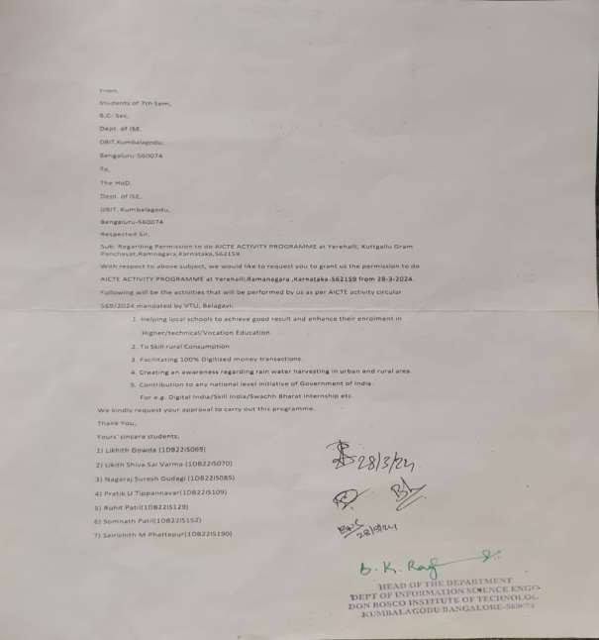

Activity- 1
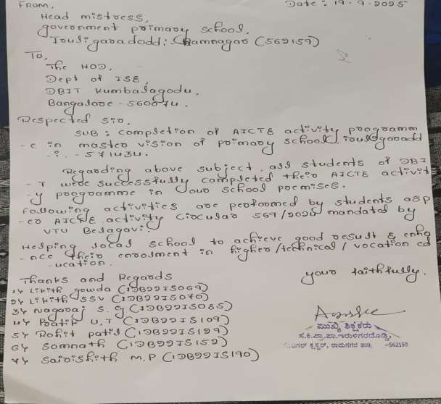

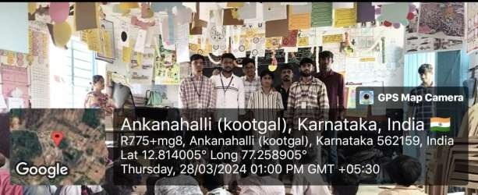

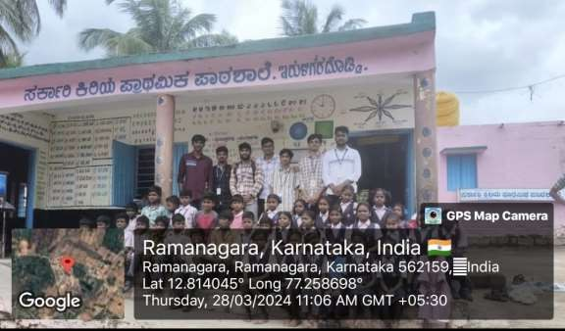

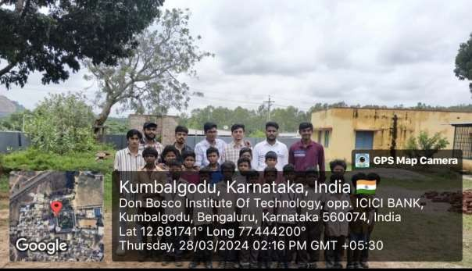

Activity-2

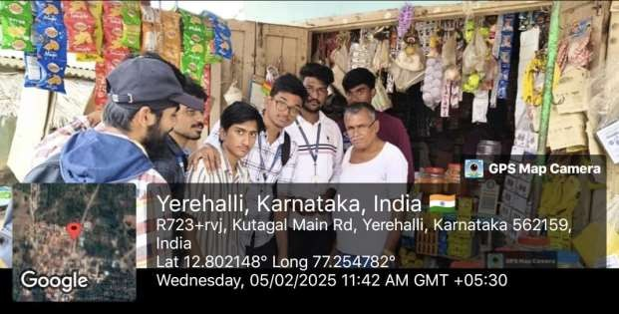

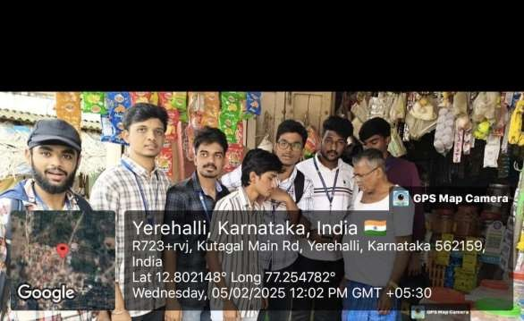

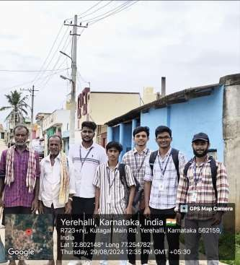

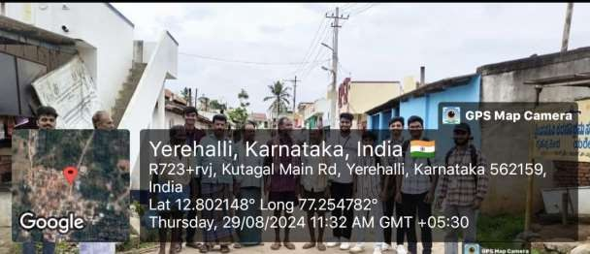

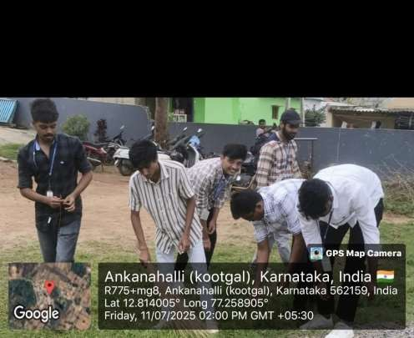

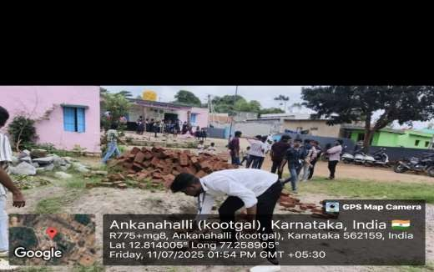

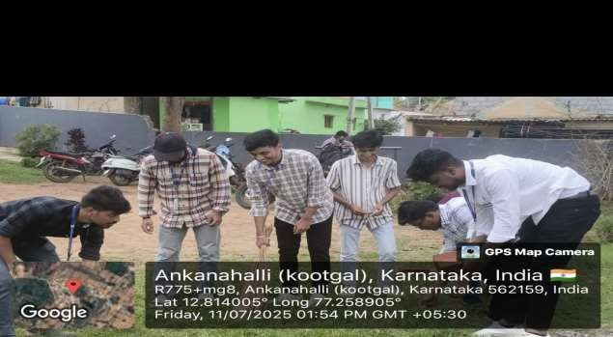
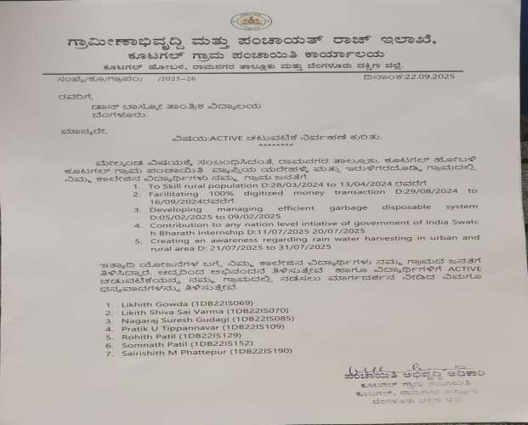

Activity 5
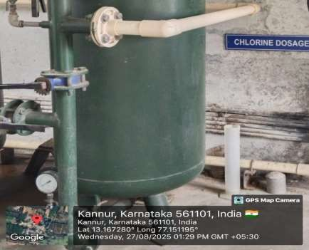

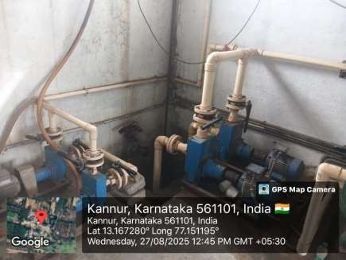

Chapter 5
Conclusion
The AICTE initiatives undertaken in education, skill development, digital transactions, waste management, and water conservation have yielded significant positive impacts on local communities. By implementing innovative and research-driven approaches, these projects have successfully addressed key challenges and fostered sustainable development.
Through personalized learning techniques and performance tracking, students have been empowered to achieve better academic results and higher enrolment rates in technical and higher education institutions. Skill development programs have provided rural populations with employment opportunities by equipping them with industry-relevant expertise. The promotion of digital transactions has enhanced financial inclusion, ensuring smoother and more secure cashless transactions, especially in underserved areas.
Efforts to establish efficient waste management systems have contributed to cleaner environments and improved public health, while awareness campaigns on rainwater harvesting have encouraged responsible water conservation practices. Despite challenges such as resistance to change, infrastructure limitations, and knowledge gaps, effective solutions—includingtraining, awareness campaigns, and community engagement—have led to significant progress.
Continuous feedback and data-driven improvements have played a crucial role in refining these initiatives, ensuring their long-term sustainability. Moving forward, further emphasis on mentorship programs, advanced skill training, technological integration in waste management, and stronger policyadvocacy for water conservation will be essential to scaling up these efforts. By maintaining a collaborative and community-centric approach, these initiatives can serve as a foundation for broader societal transformation, driving inclusive growth and long-term development.

REFERENCES

- Swachh Bharat Mission (Urban & Rural). (2021). Waste Management Strategies and Guidelines. Retrieved from https://swachhbharatmission.gov.in

- Ministryof Housing and Urban Affairs, Government of India. (2021). Guidelines on Rainwater Harvesting for Urban and Rural Development. Retrieved from https://mohua.gov.in

- National Skill Development Corporation (NSDC), India. (2022). Promoting Vocational Training in Schools: Best Practices & Case Studies. Retrieved from https://www.nsdcindia.org
- International Labour Organization (ILO). (2019). Vocational Education and Skill Development: A Pathway to Employment for Youth. Retrieved from https://www.ilo.org
- National Institute of Open Schooling (NIOS), Ministry of Education, Government of India. (2021). Vocational Education Courses. Retrieved from https://www.nios.ac.in/vocational.aspx

- Sharma, P., & Mehta, R. (2020). Technological Advancements in Rainwater Harvesting Systems: A Review of Global Practices. International Journal of Water Resources, 34(4), 210-225.

